Ex: 02 STUDENT MANAGEMENT SYSTEM Date: 18.12.2025
Name: Ajay Kumar S
Roll no: 2024503701
Aim:
To design student management system.
Description:
The webpage is created using various HTML and CSS tags. Below are the tags used along with a short description:
JavaScript Concepts Used:

• DOM Manipulation –
document.getElementById() is used to access and update HTML elements dynamically.
• Event Handling –
addEventListener("submit", ...) handles form submission.
• Objects –
Student details are stored as objects (name, roll, email, number).
• Arrays –
An array is used to store multiple student objects.
• Functions –
Separate functions are used for add, display, delete, and update operations.
• Loops (forEach) –
Used to iterate through student records and display them.
• Conditional Statements (if–else) –
Used for validation and error handling.
• Template Literals –
Used to display student data dynamically in HTML.
• Form Handling –
preventDefault() prevents page reload and reset() clears form inputs.
• Type Conversion –
parseInt() converts input values into numbers.

Code:
<!DOCTYPE html>
<html lang="en">
<head>
<meta charset="UTF-8">
<meta name="viewport" content="width=device-width, initial-scale=1.0">
<title>Student Management System</title>
<link rel="stylesheet" href="style.css">
</head>
<body>
<h1 class="heading">Student Management System</h1>
<hr>
<h2>Add Student Details :</h2>
<form id="studentForm">
<label>Name :</label>
<input type="text" id="name"><br><br>
<label>Roll No :</label>
<input type="number" id="roll"><br><br>
<label>Email :</label>
<input type="text" id="email"><br><br>
<label>Number :</label>
<input type="number" id="number"><br><br>
<button type="submit" class="addbtn">Add Student</button>
</form>
<br>
<button onclick="getStudent()" class="getbtn">Get Student Details</button><br>
<br>
<label>Enter the id for Deletion (index - 0 ) :</label>
<input type="number" id="del"><br>
<br>
<button onclick="deleteStudent()" class="delbtn">Delete Student </button>
<hr>
<h3>Update Student Number</h3>
<label>Enter Student Index :</label>
<input type="number" id="updateIndex"><br><br>
<label>New Phone Number :</label>
<input type="number" id="updateNumber"><br><br>
<button onclick="updateStudent()" class="updbtn">Update Student</button>
<hr>
<div id="studentList"></div>
<script src="script.js"></script>
</body>
</html>

let name1 = document.getElementById("name");
let roll = document.getElementById("roll");
let email = document.getElementById("email");
let number = document.getElementById("number");
let studentList = document.getElementById("studentList");
let del = document.getElementById("del");

const studentArray = [];

document.getElementById("studentForm").addEventListener("submit", function (e) {
e.preventDefault();

const student = {
stuname: name1.value,
stuRoll: roll.value,
stuEmail: email.value,
stuNumber: number.value
};

studentArray.push(student);
this.reset();
alert("Student Added Successfully");
});

function getStudent() {
studentList.innerHTML = "";

if (studentArray.length === 0) {
studentList.innerHTML = "<p>No student data available</p>";
return;
}

studentArray.forEach((stu, index) => {
const div = document.createElement("div");
div.innerHTML = `
<h3>Student ${index }</h3>
<p><strong>Name:</strong> ${stu.stuname}</p>
<p><strong>Roll:</strong> ${stu.stuRoll}</p>
<p><strong>Email:</strong> ${stu.stuEmail}</p>
<p><strong>Number:</strong> ${stu.stuNumber}</p>
<hr>
`;
studentList.appendChild(div);
});
}
function deleteStudent() {
const delIndex = parseInt(document.getElementById("del").value);

if (delIndex >= 0 && delIndex < studentArray.length) {
const removed = studentArray.splice(delIndex, 1);
alert(`Deleted student: ${removed[0].stuname}`);
getStudent();
} else {
alert("Error: Student index not found.");
}
document.getElementById("del").value = "";
}
function updateStudent() {
const index = parseInt(document.getElementById("updateIndex").value);
const newNumber = document.getElementById("updateNumber").value;

if ( index >= 0 && index < studentArray.length) {
studentArray[index].stuNumber = newNumber;
alert(`Updated number for ${studentArray[index].stuname}`);
getStudent();
} else {
alert("Error: Student index not found.");
}
document.getElementById("updateIndex").value = "";
document.getElementById("updateNumber").value = "";
}
Output:

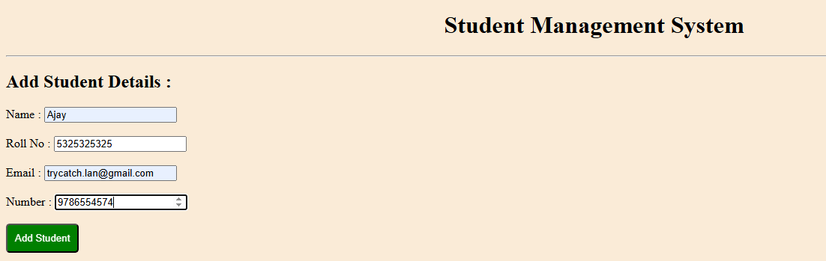
Figure(a)

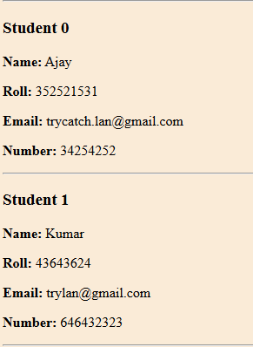
Figure(b)

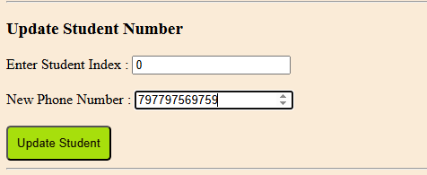
Figure(c)

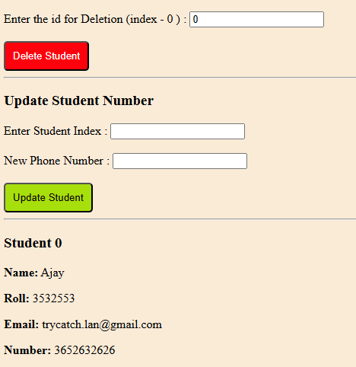
Figure(d)

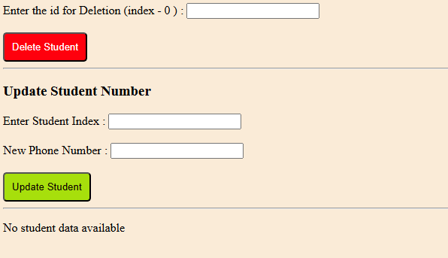
Figure(e)

Result:
Thus, the student management system is done and the output is taken successfully by performing add, delete, update, and display operations.

